Influence of external input and inhibitory synapses on the balance of a sparsely connected network of Leaky integrate-and-fire neurons.

Introduction

Neurons in the human cortical brain show an irregular firing pattern. One explanation is that the timing of the input is synchronized enough to evoke action potentials, as there is summation of input signals (Softky & Koch, 1993). A contradictory explanation says that not the timing but the frequency of the input is relevant (Shadlen & Newsome, 1998). The average input is subthreshold and because of the stochastic input it is possible to evoke spikes even though there is no synchrony.

In order to examine the hypotheses it is very useful to perform simulations on computational models of the human cortex. In computational neuroscience there are numerous neuron and network models, all of them having advantages and disadvantages. Mostly the consideration is based on the computational performance versus biological plausibility. Usually, one chooses the simplest model which still contains the minimal features to be able to answer the research question.

When examining the network dynamics of the cortex, simple neuron models are preferred, as the focus is more on the behavior of the network than on that of the single neurons. Moreover, for the examination of cortical networks the connections should be recurrent as in the human brain. Thus a commonly used network is the sparsely connected Balanced random network (Brunel, 2000; Remme & Wadman, 2012; Yger & Harris, 2013).

The balanced random network, also called balanced network, is a large scale network of sparsely connected Leaky integrate-and-fire neurons (LIF). LIF neurons only take a few parameters in account, and it is more a description of how neurons behave than what causes this behavior. The behavior of a balanced network of the simplest LIF neurons is extensively examined, both analytically and computationally (Brunel, 2000). This research showed that the balanced network could settle in four different states, based on synchrony and regularity. The key parameters in the differentiation between these four states are the amount of external input (each neuron receives stochastic background input) and the ratio between the conductance of excitatory versus inhibitory synapses.

Other studies showed that network models with more biological plausible LIF neurons can reach balanced states as well (Yger & Harris, 2013). However, it is still unknown if these networks can reach the different states of synchrony and regularity as well, and whether the transitions between these states are similar to those of the simpler neuron model. It is therefore examined whether the LIF neuron model with more biological plausible characteristics can reach balanced states which differentiate between synchrony and regularity. It is hypothesized that a balanced state will be reached, and that it is possible to differentiate between the different states, although the transitions will differ from simpler models.

This is examined by implementing a balanced network of LIF neurons and systematically quantifying the regularity and synchrony of different combinations of the external input and relative strength of inhibitory synapses. It is expected that it is possible to differentiate between the four states bases on the quantification. Whether these transitions will be nominal or continuously is unknown, as the involved parameters are not linearly correlated to one another.

Materials and Methods

**Simulations**

Simulations of the spiking neurons were performed using the BRIAN 2 simulator (Goodman & Brette, 2009) with a fixed time step and a membrane time constant of . All simulations were performed on a Packard bell EasyNote TK with 4GB RAM and 2,3 GHz AMD Athlon II P360 processor.

**Simple neuron model**

For the simple LIF neuron model (adapted from *Brunel, 2000)* the next equation is used:

where RIi(t) is described by the equation:

Where is related to the external firing rate and is described by

.

represents the fluctuating input. is described by

,

where represents the number of connections of excitatory neurons and represents Gaussian white noise. The remaining fixed parameters are the threshold , the PSP amplitude , the transmission delay , the refractory period and the reset value after a spike The remaining parameter space consists of g, which is the relative strength of the inhibitory synapses and of , the external firing rate.

The number of excitatory (NE) versus inhibitory (NI) neurons are, resembling the ratio of anatomical estimates for neocortex, respectively 1600 and 400. The sparseness of the network (ε) was originally 0.1, however, to keep the simulations feasible this value is scaled as the original number of neurons was 12500. By increasing the sparseness, even with a smaller number of neurons balance could still be reached (Golomb & Hansel, 2000). So after application of this scaling, the sparseness of the network ε = 0.4098. This means that every neuron has 0.4098 chance it receives a connection from any other neuron.

**More complex neuron model**

The more complex neuron (adapted from *Yger & Harris, 2013*) is quite similar to the simple neuron model, however the conductance of excitatory and inhibitory neurons decays according to a linear equation after a spike instead of just an event at the spike time. Moreover, the event of a spike is different from the simpler model. Whereas the simple model just increases the potential, the more complex model increases the conductance and therefore indirectly the potential increases or decrease, depending on whether the pre-synaptic neuron is excitatory or inhibitory.

In this model the equation of a neuron is:

where is the membrane conductance, here defined as . The leak conductance , the resting membrane potential , the threshold , the reset potential and the refractory period .

The synapses are modeled as instant changes of conductance followed by an exponential decay, as described in the equations:

where the excitatory and inhibitory synaptic time constant are respectively and and reversal potentials are and .

To keep the simulations feasible, 800 excitatory and 200 inhibitory neurons are used. The sparseness is .1915, scaled from .05 with 4500 neurons (Golomb & Hansel, 2000). Synaptic delays are randomly chosen from a uniform distribution between 0.1 and 5 . Initial synaptic conductances were randomly chosen from Gaussian distribution with means and with . The value for is the free parameter space. Finally, each neuron receives input from an independent Poisson spike train at 300 , through an excitatory synapse with conductance of . So the free parameter space in this model consists of the mean value of and the value for .

**Quantification of regularity and synchrony**

For the free parameters and the space between 1 and 10 is quantified for regularity and synchrony. The regularity is quantified by the coefficient of variation (CV), which is the SD of the inter-spike-intervals (ISI) divided by the mean of the ISI. The average of all CV’s of the neurons of a network are the measure for the regularity of a network.

The synchrony is quantified by the average of the 10 highest peaks of the total network frequency. The higher the frequency, the more a network is in synchrony, as more simultaneously firing leads to a higher frequency on a time step.

**Statistics**

After quantification for the parameter space is completed, statistics can be performed in order to examine whether there are states which differ significantly in regularity and synchrony. Besides color plots which could show different states according to either synchrony or regularity (or even both when a mountain color plot is produced), it only gives an indication where the flipping points are. Cluster analyses/ k-means can statistically separate different surfaces of the parameter space which differ in regularity and synchrony.

Results

**Balanced network of simple neurons**

Exploration of the free parameter space of the simple neuron model resulted in four different states, based on differences in both synchrony and regularity. The Synchronous Regular state (SR) is reached with , the Synchronous Irregular state (SI) with , the Asynchronous Regular state (AR) with and the Asynchronous Irregular state (AI) with (See Figure 1).

**Balanced network of more complex neurons**

With the initial parameter values of *Yger & Harris, 2013* () there was no balance. The external input was increased to in order the reach a balanced state. From this point a explorative simulation was conducted to find interesting ranges to see different balanced states. Simulations were conducted with between 1 and 10 and between 1 and 10 . This resulted in different states of balanced networks.

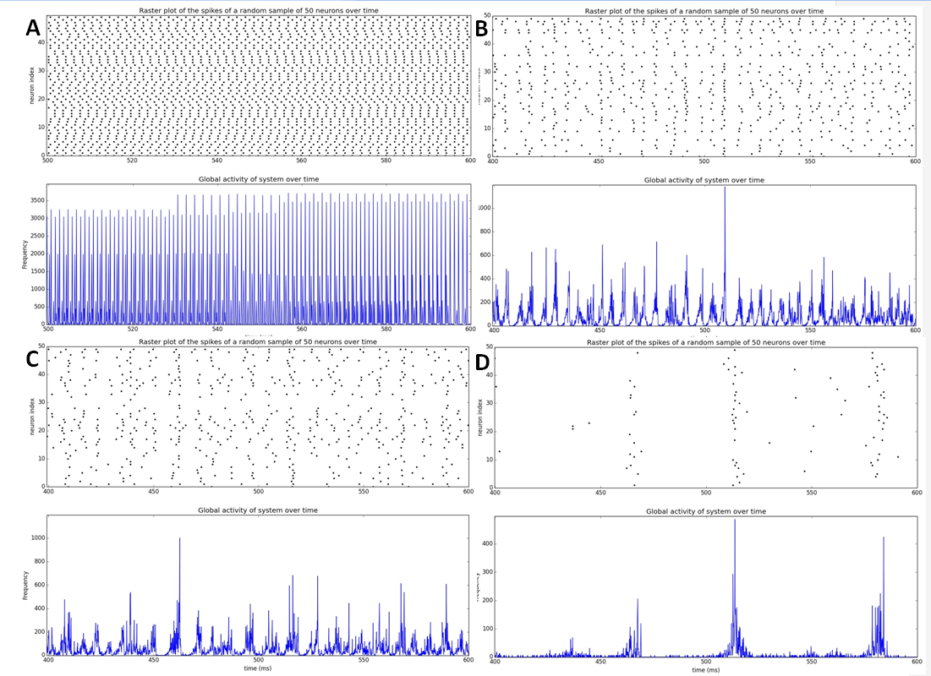

**Figure 1.** **Classification of different states of a balanced network of the simple neuron model.** Simulation of a network of 1600 excitatory and 400 inhibitory neurons with a sparseness of 0.4098. For all four situations the spiking behavior of 50 randomly chosen neurons of the population is shown in the upper plot, and the global activity of the network in the lower plot. **A.** The Synchronous Regular (SR) state, where neurons are synchronized and neurons spike regular (only the during refractory period the neurons are silent; ). **B.** The Synchronous Irregular (SI) state, where there is still synchrony in the global activity, but single neurons fire irregular (). **C.** The Asynchronous Regular (AR) state, where is much less synchrony, but single neurons do tend to fire regular (). **D.** The Asynchronous Irregular (AI) state, where the frequency is too low to speak of synchrony, and single neurons spike irregular ().

When external input was too low () there was no balance at all. When external input is increased en inhibition is kept low the network reaches the SR state. When inhibition increases, roughly between and , there appears a state not described in the simple neuron model: a Bursting Synchronous state (BS; see Figure 2). When inhibition is increased more, there arises a sort of AI state. Without quantification it is hard to determine whether there are SI and AR states. A classification of the different states by interpretation of the global activity plots is visualized in Figure 3.

**Quantification of Synchrony and Regularity**

To be able to differentiate different states objectively, a quantification measure is needed. For the Regularity the average coefficient of variation (CV) is calculated for the different values of and . A low CV value means regular behavior. CV values around 1 are similar to a Poisson process, and therefore highly irregular. The different values of the CV are plotted in Figure 4.

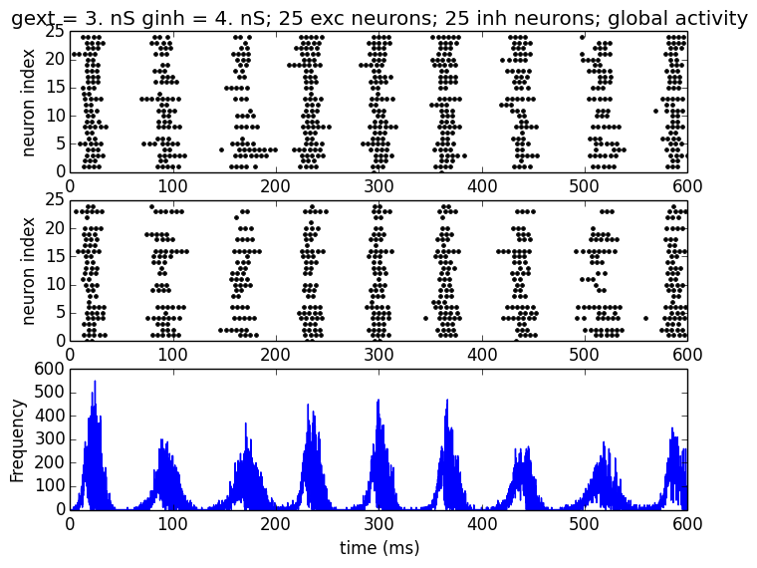

**Figure 2.**

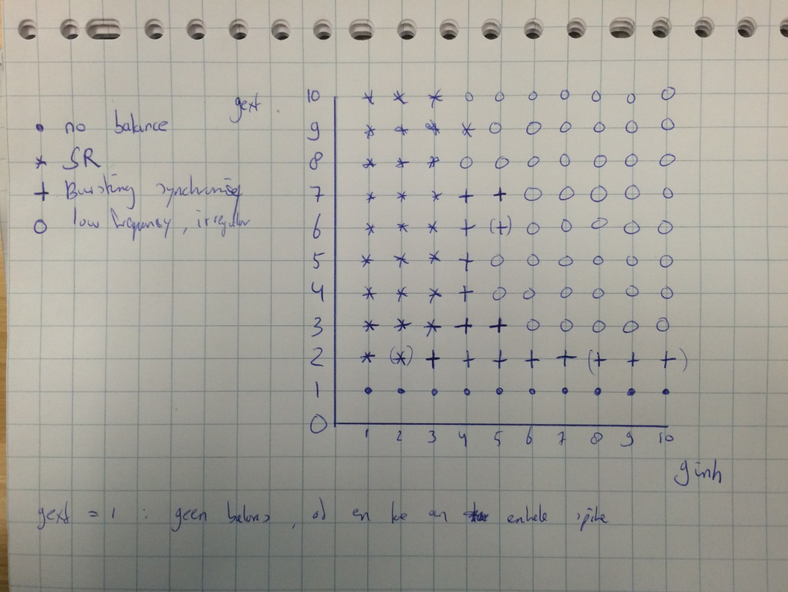

**Figure 3.**

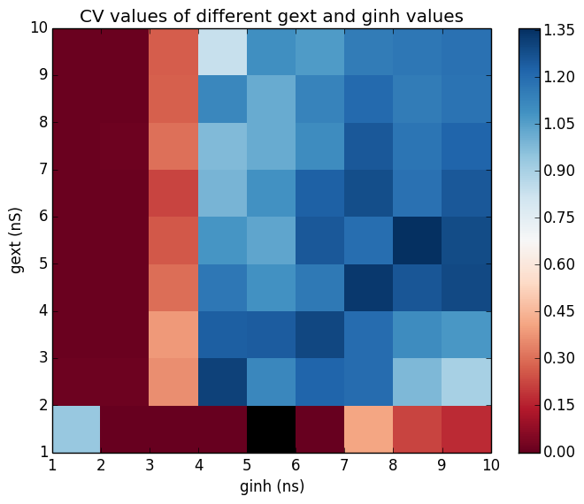

**Figure 4.**

This plot shows that values of , independent of the value of , all cause very regular spiking behavior. is a transition value, as all values of causes very irregular behavior. As mentioned before, external input should be high enough () in order to have balanced behavior. So the CV values of do not have a meaning in this case.

[PART OF QUANTIFICATION SYNCHRONY]

[PART WHERE BOTH QUANTIFICATIONS ARE COMBINED AND WHERE HOPEFULLY ORIGINATE DIFFERENT STATES]

**Statistics**

Statistically differentiate between differences in regularity and synchrony

Discussion

Framework for discussion can be found in the ‘Framework for report’ document.

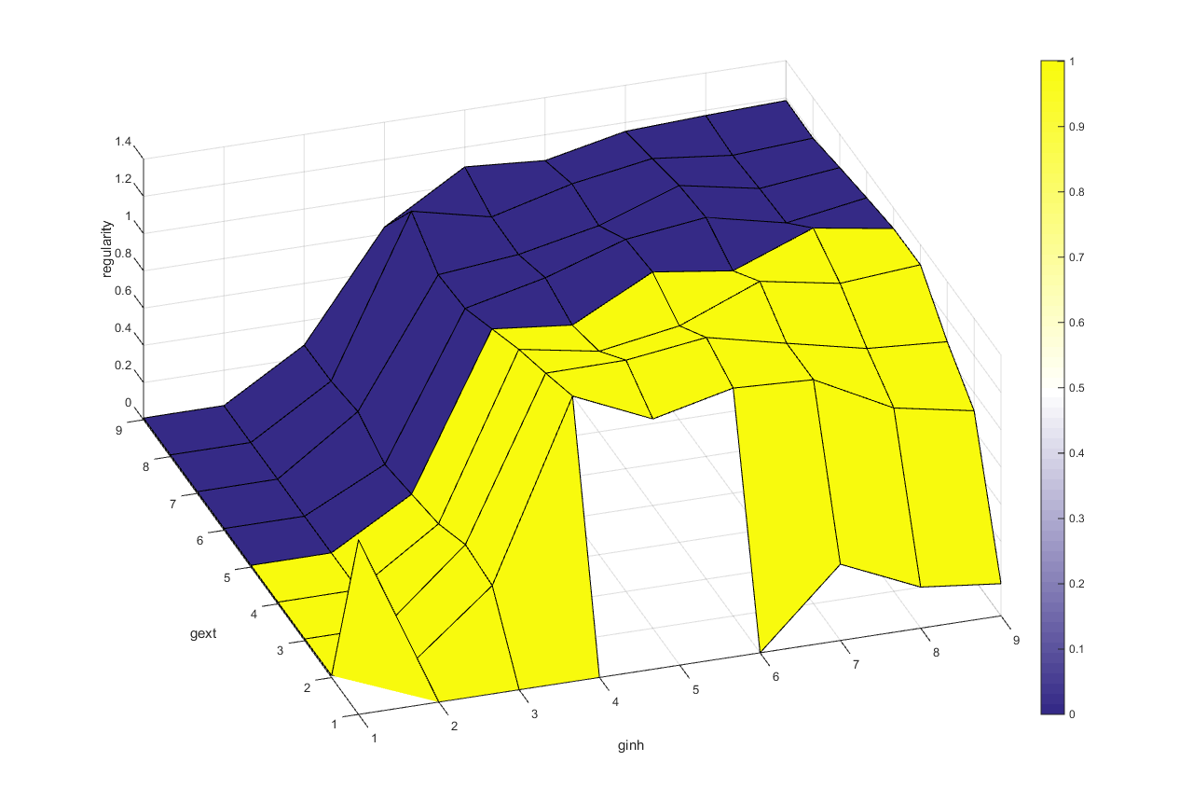

**Example figure 1. Quantification for regularity and synchrony in 1 plot. The regularity is plotted in the z-axis and the synchrony (dummy data) as colors.**

**References**

Brunel, N. (2000). Dynamics of sparsely connected networls of excitatory and inhibitory neurons. *Computational Neuroscience*, *8*, 183–208.

Golomb, D., & Hansel, D. (2000). The number of synaptic inputs and the synchrony of large, sparse neuronal networks. *Neural Computation*, *12*(5), 1095–1139. http://doi.org/10.1162/089976600300015529

Goodman, D. F. M., & Brette, R. (2009). The brian simulator. *Frontiers in Neuroscience*, *3*(SEP), 192–197. http://doi.org/10.3389/neuro.01.026.2009

Remme, M. W. H., & Wadman, W. J. (2012). Homeostatic scaling of excitability in recurrent neural networks. *PLoS Computational Biology*, *8*(5). http://doi.org/10.1371/journal.pcbi.1002494

Shadlen, M. N., & Newsome, W. T. (1998). The variable discharge of cortical neurons: implications for connectivity, computation, and information coding. *The Journal of Neuroscience : The Official Journal of the Society for Neuroscience*, *18*(10), 3870–3896.

Softky, W. R., & Koch, C. (1993). The highly irregular firing of cortical cells is inconsistent with temporal integration of random EPSPs. *The Journal of Neuroscience : The Official Journal of the Society for Neuroscience*, *13*(1), 334–350.

Yger, P., & Harris, K. D. (2013). The Convallis Rule for Unsupervised Learning in Cortical Networks. *PLoS Computational Biology*, *9*(10). http://doi.org/10.1371/journal.pcbi.1003272